Budget Rent A Car 
of British Columbia

Global Information System

Inter-branch Accounting Interface Business Design

Version 1.00

Note: The information contained in this document is confidential and may not be disclosed to any parties outside of Budget Rent a Car of British Columbia without written consent by one of its officers.
Copyright (C) 2000 Budget Rent a Car of British Columbia
Table of Contents
1. Functional Area Business Design 1
1.1. Accounts Payable and Accounts Receivable 1

1.1.1. Process Description 1
1.1.1.1. Accounting Interface Flow 1
1.1.1.2. Items Covered Under Other Business Designs Within GIS Error! Bookmark not defined.

1.1.2. Functions
1.1.2.1. Inter-branch Transaction Types
1.1.2.2. Inter-branch Zones
1.1.2.3. Revenue Splitting
1.1.2.4. Generate A/R and A/Posting Files

1.1.3. Background Processes 2
1.1.3.1. Generate A/R and A/P Accounting Entry 5
1.1.4. Test Scenario List 6
1.1.5. Security Requirements 6
1.1.6. Data Model 7
2. Revision History 9
2.1. Version 1.00 9

Functional Area Business Design

Accounts Payable and Accounts Receivable

Process Description
There is a requirement to pass information between the GIS Inter-branch Transaction and the A/P and the A/R systems. It is assumed that the A/P and A/R systems will be an integrated packaged solution from a single vendor. The following describes the interface requirements between GIS Inter-branch and each accounting system component.

Identify All the Inter-branch Transactions
Transactions Includes:
  - Contracts that involved at least one vehicle for which
- Pick up location is foreign Or
- drop off location is foreign
  - Contracts that during the lifecycle of the contract have involved a foreign vehicle

Accounting Interface Flow
As illustrated in the diagram below, generation of the daily posting files for the A/R and the G/L will be run after the close of the business day when no further transactions will be processed for that day. The following is a description of the processes shown in the diagram;
- Scheduled daily Job- Generate the AR/AP Invoice Entries
- Generate A/R and A/P Posting Files - Each day the A/R and A/P entries created for the closed RBR day will be used to create the daily posting files for the A/R and A/P systems.

Functions

Inter-branch Transaction Types
Purpose
Identify the type of inter-branch transactions
There are 3 types of Inter-branch transactions:
One Way – Owing Company of the vehicle sending the vehicle to the location that belong to another owning company
Local Rental – Renting Company rent a vehicle belong to another owning company locally
Rent back - Renting Company rent a foreign vehicle back to the location that belongs to the vehicle owing company

Inter-branch Zones
Purpose
Identify the zones of the inter-branch transaction
Currently there are there zones:
- BC/Alberta/Abbotsford/North Van
- Lower Mainland
- US

Revenue Splitting
Revenue splitting is based on the Transaction types and Zones

IB Zone: USA
Revenue Splits | Renting City Licensee
Revenue Splits | Corporate Vehicle |  | Licensee Vehicle
Revenue Splits | Owning | Renting | Owning | Renting
Revenue Splits | City | City | city | city
*Rental Revenue | 65% | 35% | --- | ---
-- to or toward Owning City | -- | -- | 65% | 35%
Local Use | 100% | 0% | 100% | 0%
Loss Damage Waiver | 65% | 35% | 65% | 35%
Personal Accident Ins | 0% | 100% | 0% | 100%
Personal Effects Coverage | 0% | 100% | 0% | 100%
Refueling Charge | 0% | 100% | 0% | 100%
Expense
Corporate car fees (Royalties) | 100% | 0% | 0% | 100%
Credit card commissions | 0% | 100% | 0% | 100%
Vehicle repairs | 100% | 0% | 100% | 0%
Reservation charges | 0% | 100% | 0% | 100%
Travel agent commission | 0% | 100% | 0% | 100%
Airline commission | 0% | 100% | 0% | 100%
Airport Concession and Airport Recovery Fee/CFC | 0% | 100% | 0% | 100%
Routine cleaning & maintenance | 0% | 100% | 0% | 100%

IB Zone: BC/ ALBERTA/Abbotsford/North Vancouver
REVENUE AND EXPEN RESPONSIBILITIES
Revenue Splits
Revenue | Rent Back |  | Authorized Local Rental
Revenue | Owning | Renting | Owning | Renting
Revenue | City | City | city | city
Rental Revenue | 50% | 50% | 100% | 0%
Loss Damage Waiver | 50% | 50% | 100% | 0%
Personal Accident Ins | 0% | 100% | 0% | 100%
Personal Effects Coverage | 0% | 100% | 0% | 100%
Drop Charge | 50% | 50% | ----- | ------
Additional Driver | 50% | 50% | 0% | 100%
Baby Seats | 0% | 100% | 0% | 100%
Ski Rack | 0% | 100% | 0% | 100%
Vehicle License Fee(VLF) | 100% | 0% | 100% | 0%
Refueling FPO | 100% | 0% | 0% | 100%
Expense
Corporate Car Fees (Royalties) | 100% | 0% | 100% | 0%
Credit Card Commissions | 0% | 100% ~ | 0% | 100%
Vehicle Repairs | 100% | 0% ~ | 100% | 0%
Reservation Charges | 0% | 100% | 0% | 100%
Travel Agent Commission | 0% | 100% | 0% | 100%
Airline Commission | 0% | 100% | 0% | 100%
Airport Concession and Airport Recovery Fee/CFC | 0% | 100% | 0% | 100%
Routine Cleaning & Maintenance | 0% | 100%: | 0% | 100%

IB Zone: Budget Vancouver & Lower Mainland
REVENUE AND EXPENSE RESPONSIBILITIES
Revenue Splits
Revenue | Authorized
Revenue | Owning, | Renting
Revenue | city | city
Rental Revenue | 90% | 10%
Loss Damage Waiver | 100% | 0%
Personal Accident Ins | 100% | 0%
Personal Effects Coverage | 100% | 0%
Drop Charge | 100% | 0%
Additional Driver | 100% | 0%
Baby Seats | 0% | 100%
Ski Rack | 0% | 100%
Vehicle License Fee(VLF) | 100% | 0%
Refueling /FPO | 0% | 100%
Expense
Corporate Car Fees (Royalties) | 100% | 0%
Credit Card Commissions | 0% | 100%
Vehicle Repairs | 100% | 0%
Reservation Charges | 0% | 100%
Travel Agent Commission | 0% | 100%
Airport Concession and Airport Recovery Fee/CFC | 0% | 100%
Routine Cleaning & Maintenance | 0% | 100%

Generate A/R and A/Posting Files
Purpose
The purpose of this process is to generate the A/R and A/P posting files which will be subsequently input into the A/R and A/P systems to post the accounting information for GIS for the business day.
Input Parameters
Start RBR Date, Ending RBR Date
External Inputs
RBR Date – Will be used to select the business day to be processed.
External Outputs
ACCPAC records for the A/R posting files are:
- IB_imarorg.xls– AR Invoice/Credit Memo
- IB_imaradj.xls – AR Debit/Credit Adjustment
ACCPAC records for the A/P posting files are (a separate file is used for each record type):
- IB_imaporg.xls– AP Invoice/Credit Memo
- IB_imapadj.xls – AP Debit/Credit Adjustment
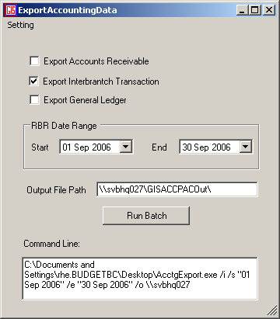

Background Processes

Get all the inter-branch contract listing
- Get all the Revenues from all these contracts
- Relate these Revenue to the transaction type, IB Zones, Vehicle ownership
- Identify the revenue ownership and revenue splitting percentage according to the transaction type vehicle ownership and IB Zone
- Generate AR/AP entries according to revenue ownership and revenue splitting percentage.
- Generate AR/AP Invoice Header and details

Remarks:
- All the foreign currency are converted to Canadian Dollar for calculation
- Revenue splitting between different vehicle units in the same contract is in place but was disable as requested.

Technical Notes
Please See Attached excel files “IB Accounting Settings.xls”

Test Scenario List

To be provided by Budget.

Security Requirements
There are no security requirements for this interface.

Data Model

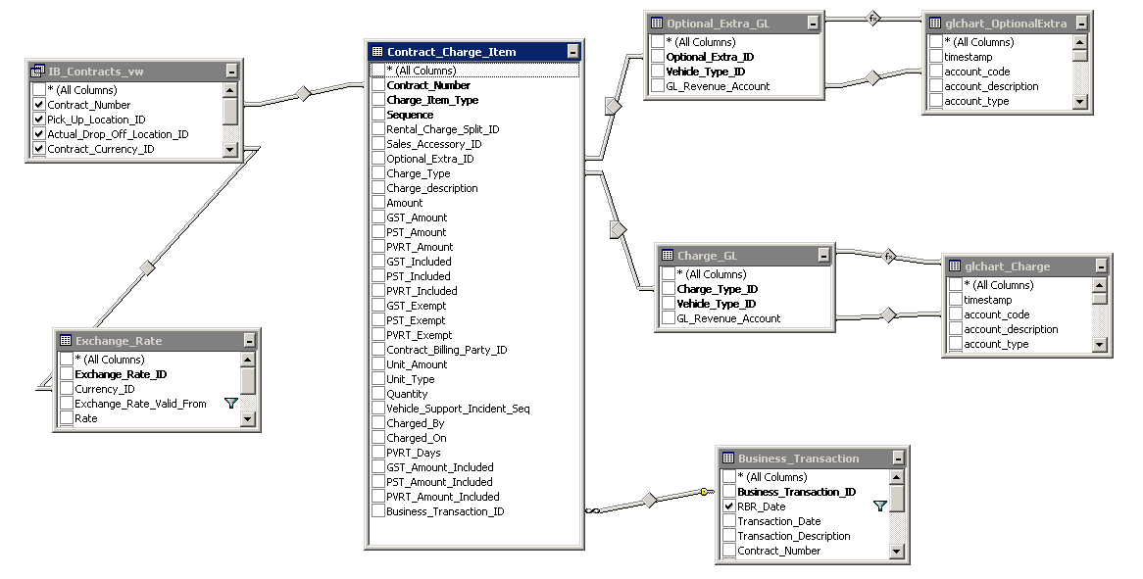
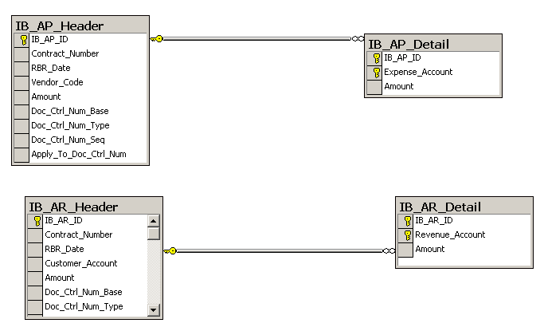

Revision History

Version 1.00
- Clean up documentation and make consistent with the GIS standards.

